FUTURE BLOOMIES
60m Fun Run!
For Youth with Physical Disabilities
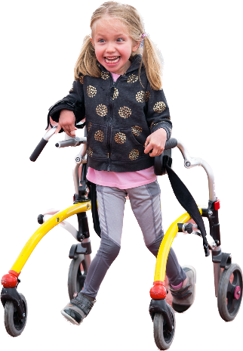
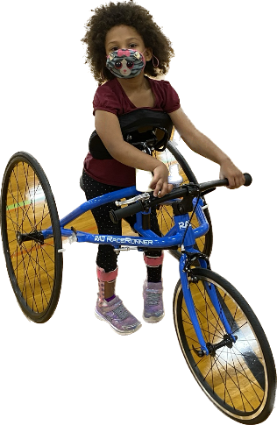
Saturday May 6th, 2023
12:30pm check-in
1:00pm start time
Numerica Skate Ribbon
at Riverfront Park
720 W Spokane Falls Blvd

Kiddos can race using their personal mobility devices.
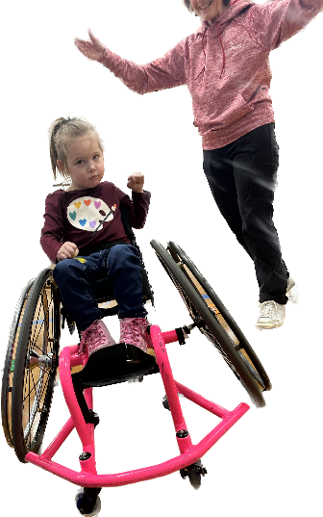
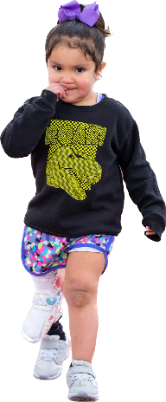
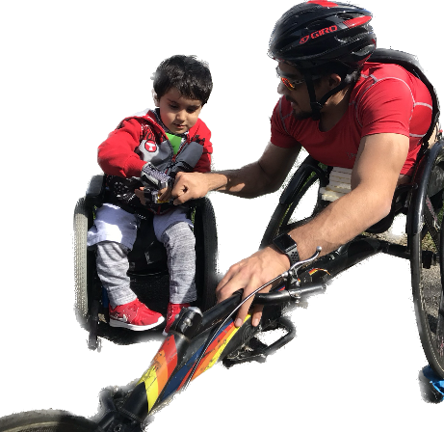
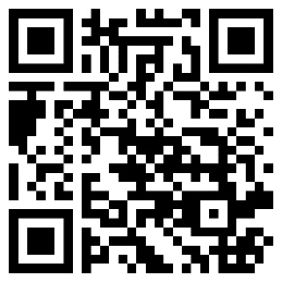
Register Here:
Future Bloomies Run

